Table of Contents
Usenix 2020 paper analysis 3
1. Scope of the paper & attack methodology 3
2. Attacks performed, how, and patch status 4
3. Coverage, limitations, and open research areas 5
4. Latest UPI market data (2026) 6
2. https://dvararesearch.com/the-use-of-malware-in-upi-related-fraud/ 7
2. Attacks/malware described, and current status 7
3. Coverage, limitations, and research gaps 9
4. Relevant recent data (fills in the "6 years / 3 years later" gap) 9
1. What the paper covers + attack methodology 10
3. Coverage and research gaps 13
4. Latest UPI protocol updates and market share 13
4. https://rscb.bank.in/Content/pdf/npcicircular.pdf 15
1. How this strengthens trust of banks using UPI 15
2. UPI's global footprint — what's in this document vs. general context 15
3. Major points banks (PSPs/TPAPs) must adhere to 16
4. Why was this needed 17
5. How this strengthens India's position in the AI era 18
6. Potential research areas 18
Timeline: major developments, 2016–2026 19
Protocol versions — what actually changed at the protocol level 20
Basic architecture 21
How Aadhaar fits in 21
How UPI is going global 22
NPCI/2025-26/IS/003 — Inferred Implementation Architecture Mapping 23
0. Framing: where these controls physically live 23
A. IDENTIFY 24
B. PROTECT 25
C. DETECT 28
D. RESPOND 28
6. https://youtu.be/26abRjVYXLY?si=FmzzxMbPA63G5iCG Is UPI Really Safe? NPCl's CRO Explains | Viswanath Krishnamurthy × Gobinath 29
7. https://www.youtube.com/watch?v=dwVGSXGUt3U The Story Behind UPI, And What’s Next: ONDC, BBPS & ULI with Deepak Thakur (NPST 29
Document 1: ShodhKosh paper (Shrimali et al., 2024) — low technical/security value, use with caution 30
Document 2: ERGO/Khaitan & Co note on OC 201-B (Nov 2025) — genuinely important, but read it for what it is 30
https://assets.kpmg.com/content/dam/kpmgsites/in/pdf/2025/07/unified-payments-interface-upi-information-security-compliance-framework-2025.pdf 32
https://www.khaitanco.com/sites/default/files/2025-11/ERGO%20-%20Enabling%20Agentic%20Payments%20%20on%20UPI%20Rails%20-%2020%20November%202025.pdf 32
https://razorpay.com/blog/what-is-upi-and-how-it-works/ 32
How Device Binding Works 32
4. https://www.reddit.com/r/UPI/comments/1v0e9vs/navi_upi_app_latest_update_flagged_as_a_trojan/ 33
18. COllect Request (UPI) – Simple Meaning (Matlab) 36
FINAL DAYS RESEARCH 37
Layer 1 — Transaction processing 37
Layer 2 — Settlement 37
SOME IMPORTANT POINTS— 40

Usenix 2020 paper analysis
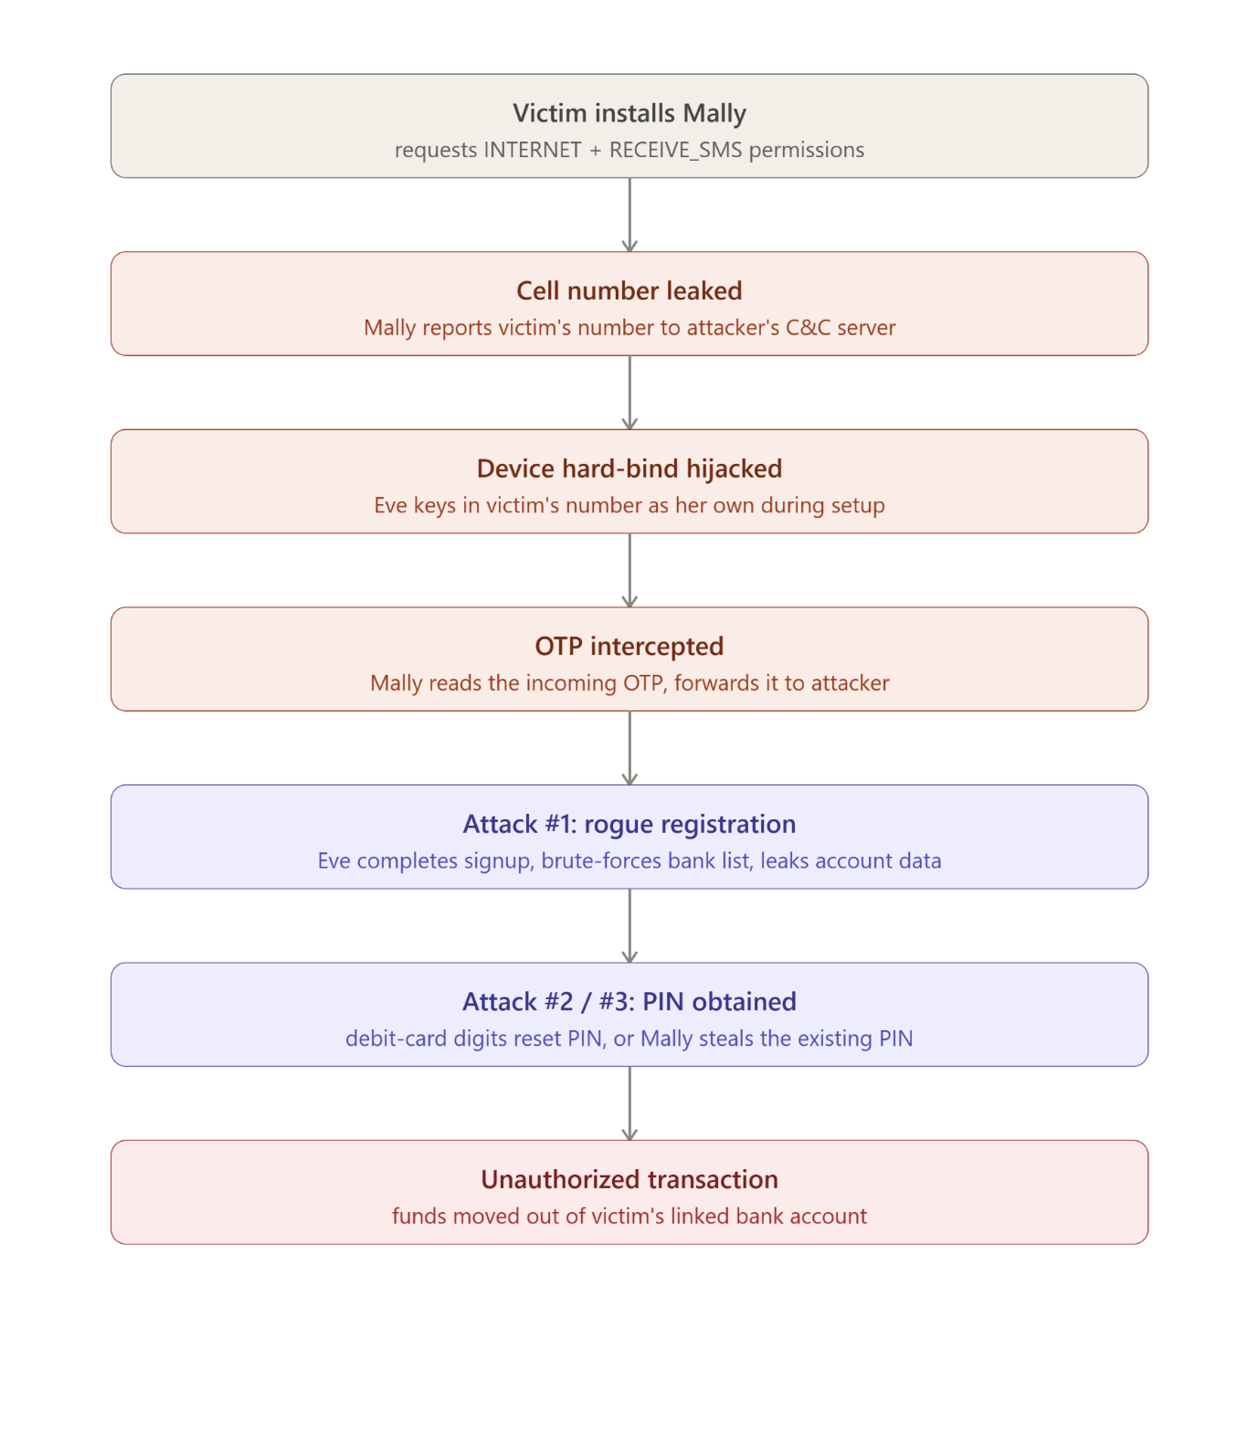

1. Scope of the paper & attack methodology
What's covered: First public security analysis of UPI 1.0 (NPCI's unpublished proprietary protocol), reverse-engineered through 7 apps (BHIM, Ola Money, PhonePe, Samsung Pay, Paytm, Google Pay/Tez, Amazon Pay) with 88% combined market share at the time. No server access — everything inferred from client-side app behavior.
Reverse-engineering methodology:
- Tried sandbox/emulator analysis (CuckooDroid) — failed, apps need a physical SIM and detect emulators/root/Xposed hooking.
- Where repackaging was possible (BHIM): disassembled with APKTool, statically instrumented smali bytecode with debug print statements, used JEB decompiler + javap for obfuscated control flow, cross-checked with MobSF and Drozer.
- Where repackaging failed (Google Pay): intercepted TLS traffic via mitmproxy over OpenVPN, forced onto older Android (Marshmallow/Lollipop) since Nougat+ blocks user-installed certs without root.
Threat model: Victim (Alice) uses a legitimate, non-rooted phone and a genuine UPI app, but has installed an innocuous-looking attacker app ("Mally") with INTERNET + RECEIVE_SMS permissions (both common/unremarkable). Attacker (Eve) uses a rooted phone with a repackaged UPI app with client-side checks disabled. No social engineering required.
Three underlying design holes (see diagram above for how they chain together):
- Device hard-binding (the "first factor") uses only harvestable device data — no real secret.
- The fallback registration workflow lets any phone bind to any cell number via OTP, since OTP delivery ≠ ownership proof if an app on the victim's phone can read incoming SMS.
- UPI leaks a user's bank account details (bank name, masked/hashed account number, IFSC) to anyone who knows just the victim's cell number — no bank credential required.

2. Attacks performed, how, and patch status
Attack | Requires | Result | Status (per paper)
#1 Rogue registration | Victim's cell number + Mally installed | Leaks which banks Alice uses + her account numbers | Root cause (alt. workflow enabling remote SMS-less hard-binding) removed in UPI 2.0/later BHIM
#1′ Same on an existing user | Above + bypassing app passcode (toast-overlay CVE-2017-0752 or accessibility permission, or exploiting weak passcode-reset flows) | Same leak, for registered users | Passcode-reset-via-leaked-account-number gap persisted into UPI 2.0 per authors' preliminary findings
#2 Unauthorized transaction, no PIN needed | Cell number + last 6 digits of debit card + expiry (no card PIN) | Full account takeover/drain, even for someone who never used a UPI app | Not fully closed as of paper — PIN-set/reset still only needs partial card data + OTP
#3 Unauthorized transaction on existing UPI user | Just an SMS + UPI PIN intercepted by Mally (via overlay/accessibility) | Full drain of an active UPI user's account | Same underlying weak-second-factor issue persisted
SMS-sender spoofing to bypass UPI 2.0's fix | — | Authors tried commercial SMS-spoofing services against UPI 2.0's Google Pay path; did not work in their tests (couldn't control sender number) | UPI 2.0 successfully blocked this specific avenue
Disclosure & patch record: Reported to CERT-IN (June/Oct 2017) and CERT-US → CVE-2017-9818/9819/9820/9821 (BHIM), plus CVE-2018-15660/15661/17400/17401/17402/17403 for other vendors, and a $5k Samsung bounty (CVE-2018-17083). NPCI's core fix was removing the SMS-less "alternate workflow 1" for hard-binding in UPI 2.0 (and later versions force-update BHIM, add IMEI/SIM/network-type to the binding fingerprint). The authors explicitly note other vulnerabilities — the bank-account-number leak and the weak PIN-reset via partial debit-card info — remained unresolved in their preliminary UPI 2.0 look.
Is this still current 6 years later? I couldn't find a public follow-up study from this same group re-testing UPI 2.0/current UPI comprehensively — that's arguably a gap you could fill. What has changed on the regulatory side:
- NPCI published a formal UPI Information Security Compliance Framework (2025) mandating CERT-IN-empanelled annual audits, MFA, secure SDK integration, zero-pending-vulnerability sign-off, and alignment with ISO 27001/PCI DSS across banks, PSPs, and third-party apps.
- Newer API Security Guidelines (OC-215/2025-26) push continuous, operational enforcement (not just point-in-time audits) around authentication, encryption, velocity controls, and purpose-bound API calls.
- These suggest NPCI has moved toward systemic, audited security governance rather than only patching individual reported bugs — but this is a compliance-framework response, not evidence that the specific device-binding/PIN-reset weaknesses from 2020 are technically closed. That would need a fresh reverse-engineering study to confirm — a very publishable gap for you.

3. Coverage, limitations, and open research areas
What the paper does well: principled reverse-engineering methodology for an unpublished financial protocol; systematic mapping of the full registration + transaction handshake; realistic Android threat model; responsible disclosure with CVEs; cross-app generalization (BHIM, PhonePe, Ola, Samsung Pay).
Limitations the authors state themselves:
- Only 7 of 88 UPI apps studied (though ~88% market share) — no automated/scalable methodology, everything manual.
- UPI 2.0 analysis is explicitly "preliminary" and "ongoing" — no full protocol re-derivation like they did for 1.0.
- No live server access at any point — all inference is client-side, so server-side defenses (rate limiting, anomaly detection, fraud scoring) are invisible to this methodology and could already mitigate some issues without protocol changes.
- SMS spoofing against UPI 2.0 was tried but not solved — left as an open thread ("currently exploring this and other SMS related attack vectors").
- No live economic/fraud-loss quantification — impact is described qualitatively ("devastating") not measured against real fraud data.
Good directions for your own research:
- Re-run this methodology against current apps (2025/2026 versions of PhonePe, GPay, Paytm, and newer entrants like Navi, CRED, super.money, WhatsApp Pay, FamApp) to see whether device-binding, PIN-reset, and account-info-leak issues are actually closed today — direct extension of "preliminary UPI 2.0" section.
- UPI Autopay / recurring mandates, UPI Lite, Credit-Line-on-UPI, and RuPay-credit-card-on-UPI are newer surfaces NPCI added post-2020 that this paper never touches — worth a fresh threat model.
- International UPI corridors (UPI now operates across ~8 countries) introduce new bank/telecom trust boundaries not analyzed here.
- NPCI's 2025 Information Security Framework and OC-215 API guidelines — an empirical audit of whether real deployments actually meet these mandated controls (a compliance-gap study) would be a natural follow-on.
- SMS ecosystem attacks (SS7, SIM swap, spoofed sender IDs) as an alternative path to the same device-binding weakness — the authors flag this as unfinished work themselves.
- Given the growing market-share fragmentation (PhonePe/GPay combined share fell below 80% for the first time in May 2026 as smaller apps grow), it's worth checking whether smaller/newer TPAPs have weaker security posture than the big two, echoing the original PhonePe/Paytm/Samsung-Pay "third-party integration is weaker"

4. Latest UPI market data (2026)
UPI processed 23.2 billion transactions worth roughly Rs 29.9 trillion in May 2026, and UPI now accounts for around 85% of digital payments in India and about 49% of global real-time payment volume. PhonePe and Google Pay's combined UPI market share fell below 80% for the first time in May 2026, dropping to 79%, as smaller apps like BHIM, Navi, super.money and WhatsApp Pay gained ground.
Latest app-level shares (May 2026, per NPCI data reported by TrakinTech):
App | Share
PhonePe | ~46%
Google Pay | ~33%
Paytm | ~8%
Navi | ~3.5%
super.money | ~1.8%
BHIM | ~1%
FamApp | ~0.85%
CRED | ~0.68%
WhatsApp Pay | ~0.65%
NPCI's 30% market-share cap on any single third-party app was first proposed in 2020 and has been delayed repeatedly, with the current deadline now December 31, 2026. To spur competition, NPCI granted third-party application provider (TPAP) approvals to 20 new companies in 2024 alone, and is easing feature-parity rules so smaller apps can get exclusive early access to new features.

2. https://dvararesearch.com/the-use-of-malware-in-upi-related-fraud/

1. What's covered & methodology
Type of work: Not empirical security research — a policy advocacy article. Evidence base: (a) qualitative field interviews with ~85 low-income, new-to-UPI users across Mumbai, Delhi, Kolhapur, Unnao; (b) secondary synthesis of RBI/NPCI advisories, threat-intel reports (Threat Fabric, Cybereason, HP Wolf Security), a Deepstrat/Dialogue FIR analysis, and news reports.
Core framing: UPI's server-side/protocol architecture is treated as fundamentally sound (2FA = device fingerprint + m-PIN); the article's thesis is that fraud happens by compromising the user/device, not the UPI backend — either via social engineering alone, or via malware that automates the same credential/OTP theft a con artist would otherwise do by phone. This is a materially different attack surface than Kumar et al.'s protocol-level device-hard-binding exploit, though both terminate in the same place: an attacker obtaining the OTP/PIN needed to complete a transaction.
Malware attack chain described (see diagram):

2. Attacks/malware described, and current status
Element | Mechanism | Status/evolution since 2023
Banking trojans (BlackRock, EventBot) | Disguised as flashlight/game/reader apps; steal login creds, m-PINs, OTPs via SMS-reading, keylogging, notification scraping | Still active category; 2026 reporting shows a large step up in sophistication (see below)
Phishing links | ~25% of FIR-analyzed fraud cases (Deepstrat/Dialogue study, Gurugram) came from a clicked link that silently installed malware or auto-read OTPs | Still the top-cited vector across 2025–2026 reporting
Malvertising | Malicious ads mimicking legit software (e.g., fake VLC/7-Zip/CCleaner download ads) | Continues; same pattern reported through 2025
Juice jacking / rogue Wi-Fi | Malware pushed via public charging ports or fake hotspots | Mentioned as RBI-flagged vectors; less prominent than app-based/social vectors in later data
Exploitation by "tech helpers" | New-to-UPI users asking informal helpers for setup assistance, who install malware under guise of helping | Cited directly from the Kumar et al. paper's field observation — a nice example of a social vulnerability the 2020 technical paper also flagged
Malware-as-a-Service (MaaS) | ~$5 average price for info-stealing malware per HP Wolf Security (2022); lowers technical barrier to entry | This commoditization trend has accelerated — see "Digital Lutera" below
Important 2023-era claim to flag as now dated: the article states malware-based UPI fraud was "not widespread" compared to pure social engineering, because UPI's layered 2FA made malware-only attacks harder to pull off without some social-engineering component. This has shifted materially by 2025–2026:
- A March 2026 CloudSEK threat report (covered by The Week) identified a toolkit called "Digital Lutera", distributed across 20+ active Telegram groups (100+ members each), that installs a malicious APK disguised as something routine (a traffic-fine notice, a wedding invite) and then manipulates the device OS itself to defeat SIM-binding and app-signature checks — directly undermining the device-hard-binding assumption that both this article and Kumar et al. treat as UPI's core safeguard. One monitored group alone processed Rs 25–30 lakh in fraudulent transactions over two days. NPCI's public response was that "robust checks and safeguards are already in place," without confirming a specific fix.
- Remote-access/screen-sharing app fraud (AnyDesk, TeamViewer, QuickSupport) — foreshadowed in the 2023 article's mention of Paytm disabling UPI on devices with such apps — has become one of the dominant 2025–2026 fraud patterns, per multiple sources, now often layered with "digital arrest" impersonation scripts and AI voice-cloning.
- RBI/NPCI data: UPI fraud rose 85% in FY24 and continued that trajectory through 2025; NPCI reported roughly 632,000 UPI fraud incidents by September 2024 with FY25 projections near 1.1 million.
So the article's "malware-aided fraud is a minority relative to pure social engineering" claim is directionally still true, but the two have increasingly merged (malware-assisted social engineering, e.g., OTP-bots impersonating delivery alerts), and the malware itself has gotten materially more capable (OS-level manipulation vs. simple permission abuse).

3. Coverage, limitations, and research gaps
What this piece does well: grounds the malware discussion in real low-income user experience (an angle the more technical Kumar et al. paper doesn't cover); connects fraud vulnerability explicitly to device affordability/security divide (older phones, no-name manufacturers, no OS updates); is refreshingly candid that permission-consent UX ("lengthy T&Cs users click through") is itself a vulnerability, not just a technical flaw.
Limitations:
- No independent technical analysis — it's a literature/interview synthesis, not original malware reverse-engineering (unlike Kumar et al.).
- Relies on a single 2019–2020 FIR dataset (Gurugram) for its "25% via phishing link" statistic — narrow and geographically limited, now 5+ years old.
- Doesn't quantify how much of "malware-aided" fraud is actually malware-only vs. malware plus a social-engineering call — a distinction that matters a lot for designing mitigations.
- Predates UPI's newer surfaces (Autopay, UPI Lite, credit-line-on-UPI) and predates the 2025–2026 device/OS-level manipulation techniques (Digital Lutera) — so its threat model is somewhat stale relative to where the fraud ecosystem has moved.
Good research directions this opens up for you:
- A direct technical follow-up: reverse-engineer a sample of the newer OS-manipulating toolkits (Digital Lutera-class) the way Kumar et al. reverse-engineered BHIM — is SIM-binding really being defeated at the OS layer, or is it a rooting/Magisk-style trick?
- Quantify the malware-vs-pure-social-engineering split with more recent I4C/NCRB FIR data (2024–2026) instead of the 2019–2020 Gurugram sample this article relies on.
- Evaluate whether RBI's newer mandates (AI/ML fraud monitoring, zero-trust bank architecture, mandatory device-SIM binding via DoT, biometric authentication for transactions >₹10K) are actually closing the gap this article identifies, or just adding friction without addressing the malware-permission-abuse root cause.
- A user-research angle matching this paper's own method: re-run the low-income/new-to-UPI interview study in 2026 to see if awareness has improved given NPCI/RBI campaigns since 2023 — a natural extension given Dvara's own stated "unfinished agenda" of awareness-campaign gaps.

4. Relevant recent data (fills in the "6 years / 3 years later" gap)
- UPI fraud cases: ~77,000 (FY21) → 84,000 (FY22) → 95,000 (FY23, as cited in this article) → an 85% jump in FY24 → roughly 632,000 incidents by Sept 2024 with ~1.1 million projected for FY25 (note: these are not perfectly comparable metrics across sources/years, so treat as directional, not a clean trendline).
- High-value fraud (>₹1 lakh) reportedly quadrupled to nearly ₹40 billion in 2024.
- Regulatory response has moved from "advisories" (the 2023 article's framing) to binding mandates: RBI now requires AI-enabled fraud monitoring and zero-trust architecture at banks/NBFCs, and DoT plans mandatory device-SIM binding plus a reworked Financial Fraud Risk Indicator.
- 2026's dominant fraud patterns per multiple sources: fake/manipulated QR "collect requests," remote-access screen-sharing scams, SIM-swap, and AI voice-cloning-driven "digital arrest" impersonation — a mix of the social-engineering vectors this 2023 article covers plus newer AI-driven techniques it couldn't have anticipated.

3. https://www.cloudsek.com/blog/weaponizing-lsposed-remote-sms-injection-and-identity-spoofing-in-modern-payment-ecosystems#a-upi-exploitation-and-cashout-operations, https://medium.com/@sanskarrajakofficial/digital-lutera-how-runtime-hooking-manipulates-banking-apps-a-reverse-engineering-analysis-285f22e03a3d

1. What the paper covers + attack methodology
Both documents describe the same malware family, "Digital Lutera," analyzed independently by a fraud-research/appsec team (slice) and by CloudSEK. The core subject is not a new UPI vulnerability — it's a shift in attack technique from modifying the payment app to modifying the Android OS around the app using the LSPosed runtime-hooking framework (successor to Xposed/EdXposed). https://github.com/lsposed/lsposed
Two distinct methodologies are actually described, representing an evolution:
Older method — repacked/modified APK: the attacker runs a tampered copy of the payment app on their own device. Because the APK itself is altered, its signature changes, and its custom code silently redirects the outgoing SIM-binding SMS to a Telegram bot instead of the carrier.
Newer method — Digital Lutera / LSPosed: the attacker uses a genuine, unmodified payment app, and instead hooks the underlying Android APIs (SmsManager.sendTextMessage, getLine1Number, SubscriptionInfo.getNumber, the SMS content provider) so that the app itself is deceived about what's happening on the device. This keeps the app's digital signature intact, defeating signature/integrity checks that used to catch the first method.
Both methodologies still require a compromised victim device (via a trojanized APK disguised as something innocuous) that has SMS read/write/forward permissions — the attacker's own rooted phone alone isn't enough.
Here's the overall attack lifecycle as a sequence diagram:
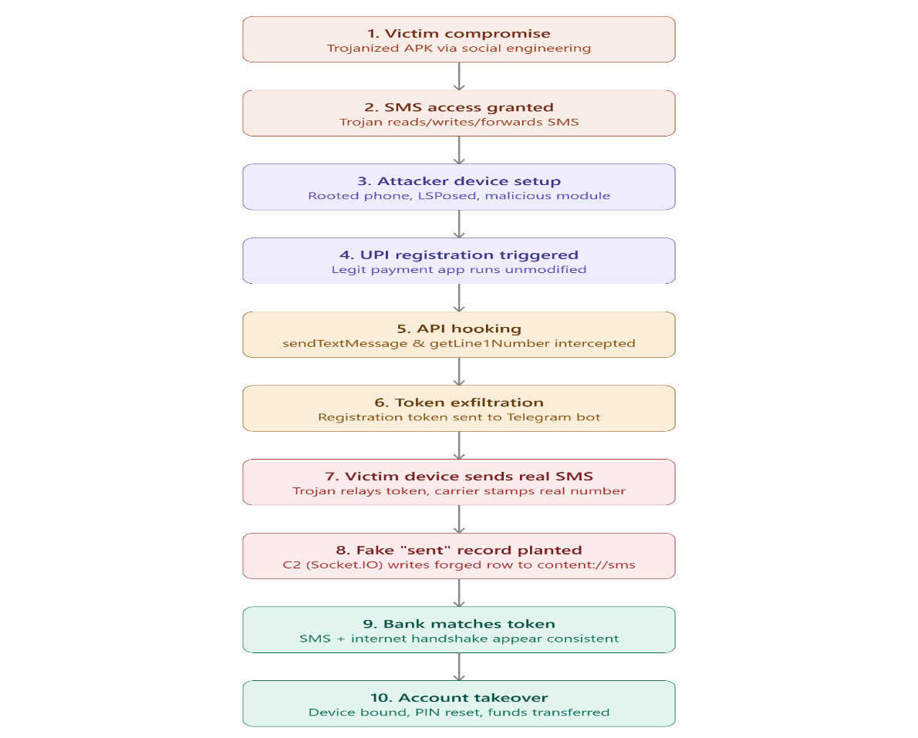
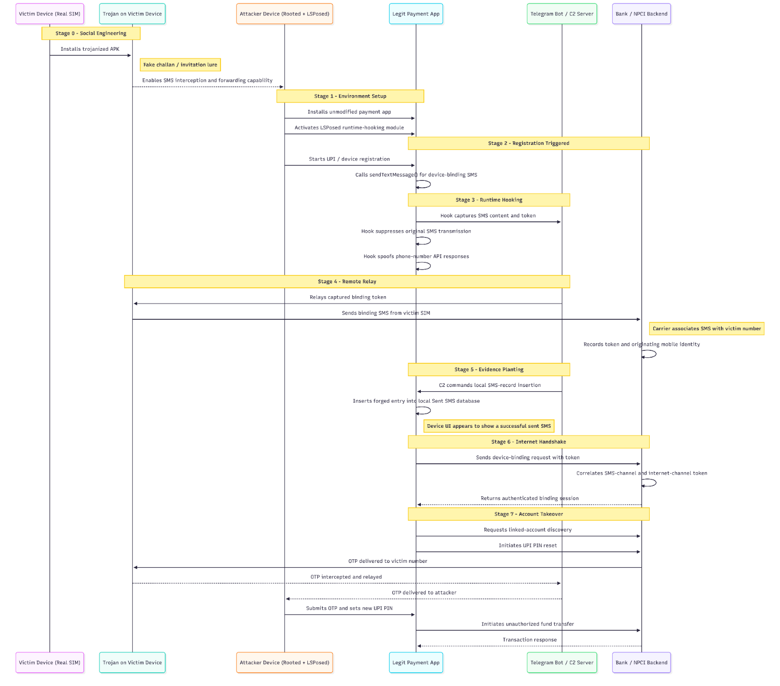tt
How the fraud actually worked (as documented): the attack never breaks bank backend systems or the UPI protocol itself. It exploits the fact that banking apps trust signals reported by the phone's OS (the SIM number, whether an SMS was sent, and its content). Two techniques were used to fake those signals — a repacked APK (older, easily flagged because the signature changes) and, more recently, LSPosed-based runtime hooking (harder to flag because the app binary is untouched). Both still require a compromised victim phone as the actual SMS gateway — the attacker's own device never touches the victim's SIM directly.
Has NPCI patched it? There's no single "patch," because this isn't a protocol vulnerability — it's an assumption (that client-reported signals are trustworthy) being abused. What has actually happened:
- NPCI publicly responded within days of the CloudSEK report, stating that UPI's multi-layer safeguards are already in place and that it continues to work closely with banks and ecosystem partners to monitor risks and strengthen security measures.
- Separately (not a direct reaction to this specific report, but relevant), NPCI issued a 2025 Mobile Application Security Framework that mandates banks/PSPs implement Runtime Application Self-Protection (RASP), hook-framework detection, anti-tampering checks, and stronger SIM/device-binding rules — including token expiry limits, rate limits on registration attempts, and blocking registration over Wi-Fi-only/no-SIM states.
- RBI separately mandated stronger two-factor authentication for digital payments effective April 2026.
So the honest answer is: NPCI/RBI have tightened the surrounding compliance framework rather than releasing a single fix, and public reporting shows they consider existing layered controls (device binding, RASP, bank-side risk scoring) sufficient — while researchers argue those controls can still be defeated by OS-level hooking unless banks specifically detect frameworks like LSPosed/Frida and move to hardware-backed attestation (Play Integrity MEETS_STRONG_INTEGRITY).
3. Coverage and research gaps –imp
What the two documents cover well:
- Reverse-engineering methodology (manifest/permission analysis, JADX decompilation, identifying Xposed module markers)
- A full code-level walkthrough of the four core malware components (SMS hook, C2/RAT service, SMS-database inserter, config manager)
- Attribution work tying the toolkit to a specific developer/persona and a broader "modding-to-fraud" community pipeline
- A clear set of bank-side remediations (Play Integrity, RASP, native-code logic, carrier-side validation, cert pinning)
What's not covered / open research areas:
- No empirical fraud-loss data — the reports describe capability, not measured financial impact or number of confirmed victims/losses.
- No analysis of iOS exposure (this is Android-specific since iOS doesn't allow this class of runtime hooking without jailbreak — worth confirming explicitly).
- No testing of how effective NPCI's existing RASP mandate actually is in practice against LSPosed specifically (detection evasion techniques for LSPosed exist and aren't addressed).
- Limited detail on the "victim compromise" vector itself (how the trojanized APKs are distributed at scale, what fraction of SMS-permission apps on the Play Store might carry this).
- No coverage of whether Google Play Protect or Android's evolving anti-Xposed detections have since been updated to catch this specific module.
- No independent verification of the actor attribution (Telegram OSINT is suggestive, not conclusive).
- No discussion of cross-border/UPI-international implications now that UPI is expanding overseas.

4. Latest UPI protocol updates and market share
Recent protocol/security changes (2025–2026):
- RBI mandated two-factor authentication for all digital payments, effective April 1, 2026.
- NPCI's 2025 Mobile Application Security Framework requires RASP, anti-hooking/anti-tampering detection, harmful-app monitoring, and stricter SIM/device-binding token rules (35+ character tokens, ≤45 second expiry, lockout after repeated registration attempts).
- P2P "Collect" requests were discontinued industry-wide from October 1, 2025 to cut down social-engineering fraud vectors.
- UPI Lite's wallet holding limit was raised to encourage more offline, low-connectivity usage, and a new dynamic load balancing protocol was rolled out to reduce transaction failures during peak load.
- NPCI has repeatedly delayed its proposed 30% market-share cap on any single third-party app, with the deadline now pushed to December 31, 2026.
- NPCI is also building common, interoperable UPI soundbox infrastructure so merchants don't need separate hardware per app.
Market share (by transaction volume, most recent NPCI data, May 2026):
App | Share
PhonePe | ~46.3%
Google Pay | ~32.8%
Paytm | ~7.9%
Navi | ~3.6%
Super Money (Flipkart) | ~1.8%
BHIM | ~1.0%
FamApp | ~0.9%
CRED | ~0.7%
WhatsApp Pay | ~0.65%
Axis Bank apps | ~0.6%
Notably, PhonePe and Google Pay's combined share fell below 80% for the first time in May 2026, and the top three players' combined share shrank from about 95% in January 2024 to roughly 87% by May 2026 as smaller apps gain ground.
that Digital Lutera requires a rooted attacker device, an active LSPosed install, and a separately compromised victim phone — means it's a targeted fraud technique, not a scalable mass exploit against ordinary users who haven't installed a malicious APK.

4. https://rscb.bank.in/Content/pdf/npcicircular.pdf

1. How this strengthens trust of banks using UPI
- Reduces the "weakest link" problem. UPI is only as trustworthy as its least-secure participating app. By making root/jailbreak detection, anti-tampering, and RASP mandatory across all PSPs/TPAPs, NPCI closes the gap where one poorly-secured app (say, a smaller regional bank's app or a TPAP) becomes the entry point for fraud that damages trust in the entire network.
- Shared, auditable baseline. A CERT-IN empanelled auditor sign-off, submitted annually, gives every bank a verifiable assurance that counterparties on the UPI rails meet the same bar — this is classic third-party risk mitigation, which matters a lot in a four-party model (payer PSP, payee PSP, remitter bank, beneficiary bank) where one bank has no direct visibility into another's app security posture.
- Reduces fraud-driven reputational and financial risk. Controls like OTP auto-read restrictions, sender-ID whitelisting, and screen-overlay/tapjacking prevention directly target the fraud vectors (SIM-swap, overlay attacks, screen mirroring scams) that have caused real financial-loss disputes between banks — fewer disputes, less TAT (turnaround time) friction, less regulatory scrutiny per bank.
- Signals maturity to RBI. Self-regulation at this granularity (OWASP Top 10, SAST/DAST, key management, RASP) is the kind of proactive governance that keeps RBI from having to step in with heavier-handed rules — which itself is a trust dividend for the ecosystem as a whole.

2. UPI's global footprint — what's in this document vs. general context
What the circular says: nothing. This is a purely domestic security-hardening circular for apps operating under Indian NPCI/UPI rules. It does not reference NPCI International Payments Ltd. (NIPL), cross-border acceptance, or any other country's regulator.
General context (from public knowledge, not this document) on where UPI-linked acceptance has been rolled out, roughly by year — treat these as approximate, since coverage and depth vary (some are "Indian tourists can pay," others are deeper interoperability):
Country | Approx. year | Nature
Bhutan | 2021 | Full UPI QR acceptance
Singapore | 2023 | UPI–PayNow real-time linkage
UAE | 2023 | Merchant QR acceptance
Nepal | 2022 | UPI-like/NPCI-assisted rollout
Sri Lanka, Mauritius | 2024 | UPI QR + RuPay acceptance
France | 2023–24 | UPI acceptance (Lyra/Eiffel Tower pilot)
Saudi Arabia, Qatar | ~2024 | Merchant acceptance pilots
Regulatory/compliance angle for RBI/NPCI when UPI goes cross-border:
- Each destination country's central bank and payments regulator has to bilaterally approve interoperability (e.g., MAS in Singapore, UAE Central Bank).
- RBI's own cross-border payment and FEMA (Foreign Exchange Management Act) rules govern how rupee-denominated UPI transactions settle against foreign merchant accounts.
- Data localization requirements (RBI's 2018 payment data storage mandate) create friction when a foreign acquirer or PSP is in the settlement chain — where transaction data physically sits becomes a negotiated point.
- AML/CFT (anti-money-laundering) alignment is needed with FATF-consistent regimes in each partner country.
- Geopolitical/security complications (again, general knowledge, not from the document): sanctions-exposure risk if UPI touches jurisdictions under US/EU sanctions regimes; data-sovereignty pushback in countries with strict local-processing laws; and the general strategic sensitivity of India exporting payment-rail infrastructure as a soft-power/digital-diplomacy tool, which invites scrutiny similar to what's happened with other cross-border payment systems in geopolitically contested corridors.
Why this matters for the circular's context: a mobile-app-security framework like this becomes a precondition for international scaling — no regulator abroad will accept UPI acceptance without confidence that the apps in the chain meet baseline anti-fraud/anti-tampering standards. So while the circular is domestic, it's arguably infrastructure work in service of the international ambition.

3. Major points banks (PSPs/TPAPs) must adhere to
Structured exactly as the circular's own Identify → Protect → Detect → Respond (NIST CSF-style) framing:
Identify
- Root/jailbreak detection + root-cloaking detection (mandatory) — block app on rooted devices
- Installation-source validation (mandatory) — only official app stores, actively hunt/remove rogue clones including on the dark web
- Harmful/blacklisted app detection, virtual device/emulator detection, device blacklisting (recommended)
Protect (the bulk of the circular, mostly mandatory)
- Runtime code/data integrity checks (memory integrity, runtime behavior monitoring)
- Anti-debugging (detect ptrace/gdb, timing-based checks)
- Code obfuscation + AES-256 (or stronger) key encryption with proper key management
- OWASP Top 10 mitigation via patch management + SAST/DAST + secrets detection + SCA (software composition analysis)
- Screen obfuscation/masking on backgrounding, screenshot prevention
- Proxy detection + access control (IP whitelisting, geolocation checks)
- VPN detection (recommended)
- SSL pinning (max 3 public keys)
- App lock (biometric preferred), APK locking, least-privilege permissions
- Developer-option/USB-debug/wireless-debug (ADB) detection and blocking
- Auto-read OTP restricted to SMS only (no manual entry, no call-based OTP), sender-ID whitelisting
- Forced updates + deprecation of old app versions
- SMS delivery confirmation to legitimate VMNs during device binding
- iOS private API whitelisting via registered Application ID
- Anti-instrumentation (block Frida/Cycript/Ghidra), anti-keylogger, anti-screen-overlay (tapjacking), anti-reverse-engineering, anti-screen-mirroring
Detect
- Tamper detection on code/memory/config with customizable automated response (restore from secure backup, degrade performance, or kill app)
- Unsecured Wi-Fi detection/alerting (recommended)
Respond
- Real-time alerting to monitoring systems with threat type, affected component, timestamp
- Automated response (revoke access, trigger countermeasures/updates)
Compliance/audit obligation
- Annual CERT-IN empanelled auditor certification, submitted alongside UPI Information Security Compliance Framework-2025 compliance, due on or before December 31 each year.

4. Why was this needed
- Threat landscape shift. The circular explicitly cites the "ongoing evolution of digital payments and increasing sophistication of cyber threats, frauds and crimes" — India has seen a sharp rise in overlay attacks, screen-mirroring/remote-access scams (fake tech support, AnyDesk-style frauds), SIM-swap OTP theft, and instrumentation-based tampering (Frida-based fraud toolkits) targeting UPI apps specifically because UPI is now the dominant retail payment rail in India (tens of billions of transactions/month).
- Fragmented baseline previously. The 2020 circular only addressed RASP; this consolidates and substantially expands controls (root detection, anti-instrumentation, screen mirroring, proxy/VPN detection) that weren't uniformly mandated before, closing gaps that fraudsters were actively exploiting.
- TPAP proliferation risk. With more third-party app providers (beyond bank-owned apps) accessing UPI rails under the multi-bank model, NPCI needed a uniform floor so a weaker TPAP doesn't undermine confidence in stronger bank apps.
- Regulatory/audit accountability. Mandating CERT-IN-empanelled third-party audits (not self-attestation alone) reflects lessons learned from earlier compliance regimes where self-certification proved insufficient.

5. How this strengthens India's position in the AI era
- AI-era fraud requires AI-era defenses. Many of the attack techniques this circular defends against (automated bot attacks via emulators, dynamic instrumentation, behavioral-pattern fraud) are increasingly AI-assisted — deepfake-enabled social engineering feeding into overlay/screen-mirroring attacks, and ML-driven automated fraud bots that need emulator/virtual-device detection to counter. This circular pre-hardens the rails against AI-augmented attackers.
- Behavioral analytics infrastructure. Requirements like runtime behavioral monitoring, tamper detection with "customizable actions," and real-time alerting create exactly the telemetry pipelines needed to later layer ML-based fraud-detection models — this circular is effectively laying groundwork data infrastructure for AI-driven fraud analytics at the bank/NPCI level.
- Digital Public Infrastructure (DPI) credibility. India is actively positioning UPI/Aadhaar/DPI stack as an exportable model for other Global South nations. A demonstrably robust, auditable security framework strengthens that pitch — countries considering adopting India's DPI model (or interoperating with UPI) will look at frameworks exactly like this as evidence of maturity.
- Talent and standards leadership. Detailed mandates around SAST/DAST, RASP, and CERT-IN empanelled auditing build a domestic ecosystem of security professionals and audit firms with deep fintech-security expertise — this is workforce/capability building that compounds over time, relevant to India's broader AI/tech soft-power ambitions.

6. Potential research areas
- RASP effectiveness benchmarking — build a testbed comparing detection rates of different root-cloaking/Frida-hiding techniques (e.g., Magisk Hide variants, Shamiko) against common RASP SDKs; quantify false positive/negative rates.
- ML-based anomaly detection on the "Detect" layer — using the tamper-detection telemetry categories the circular describes (system calls, file access, network patterns), prototype a lightweight on-device or edge anomaly classifier and compare against rule-based tamper detection.
- OTP/SMS-based social engineering resilience — study how sender-ID spoofing and OTP-relay attacks (SIM swap, OTP-relay malware) can still bypass sender-ID whitelisting; propose cryptographic or app-attestation-based alternatives to SMS OTP.
- Screen-overlay/tapjacking detection techniques — comparative study of Android's accessibility-service abuse detection methods vs. this circular's mandated approach; potential for a formal detection algorithm.
- Cost-benefit/adoption-friction analysis — a compliance-economics study: interview or survey smaller PSPs/TPAPs (cooperative banks like RSCB itself are a great case study) on implementation cost/complexity of CERT-IN audit + RASP integration vs. large banks — relevant policy research on whether uniform mandates disproportionately burden smaller players.
- Formal comparison to global standards — map this framework against PCI-MPoC, PSD2/SCA (EU), and OWASP MASVS to identify gaps/overlaps — useful if you want an angle connecting back to the international UPI expansion question.
- Adversarial ML angle — if your background leans ML: model how attackers could use generative AI to synthesize behavioral patterns that evade the "behavioral analysis" reverse-engineering detection (point 22 in the circular) — a red-team research paper.

E.List all the major developments in upi since it's induction .2016 to till date 2026. What all protocols have been introduced. Various versions of the protocols. What is the basic architecture. How addhar has come into the picture. How upi is becoming global

Timeline: major developments, 2016–2026
Date | Development
Apr 11, 2016 | UPI piloted by NPCI with a small group of banks in Mumbai
Aug 25, 2016 | UPI officially launched for public use; banks begin publishing UPI-enabled apps
Dec 30, 2016 | BHIM app launched by PM Modi (post-demonetization push) — NPCI's own reference UPI app
2017 | UPI crosses 12.5M BHIM users; Union Budget announces referral/cashback incentives; first UPI transaction-fee proposals from banks
2018 | UPI 2.0 launched (Aug 16) — see protocol table below
2019 | UPI enabled for Play Store app/in-app purchases (Sept); Google adds UPI for YouTube Premium/Music
2020 | Kumar et al. USENIX Security paper published (the one you read); UPI AutoPay facility introduced (recurring payments/standing instructions)
2021 | UPI crosses $100B in monthly value; WhatsApp Pay's user cap (20M) lifted (June); Bhutan becomes first foreign country to adopt BHIM UPI
2022 | UPI Lite launched (Sept, Global Fintech Fest) — on-device wallet, offline-capable use cases; UPI123Pay launched (March) — UPI for feature phones via IVR/missed-call/app; UPI registration enabled without a debit card (March) — direct relevance to Aadhaar's growing role, see below; NPCI removes 30%-cap enforcement delay disputes begin; BHIM goes open-source (Nov)
2023 | International UPI expansion begins in earnest — France (Eiffel Tower, Feb), NRE/NRO account access from 10 countries (Apr); Paytm Payments Bank UPI Lite live; Dvara Research malware-fraud article (the second document you shared) published
2024 | Credit-linked UPI groundwork; UPI Lite auto-top-up (Nov); Singapore-India remittance via BHIM/Paytm/PhonePe (Jan); UPI introduced in Mauritius (Feb); Project Nexus (BIS-led multilateral real-time payments interlink) founding agreement (June); NPCI grants 20 new TPAP approvals to diversify the app market
2025 | Major security-framework year: NPCI Mobile App Security Framework (May), OC-215 API Security Guidelines (May, enforced Aug 1), UPI Information Security Compliance Framework 2025, SIM/device-binding hardening, Additional Authentication Methods circular (Oct); Credit Line on UPI launches (end Aug); UPI fully live in Qatar (Feb)
2026 | UPI live in Israel (Feb) and Cambodia (June); PhonePe+GPay combined share dips below 80% for first time (May) as NPCI's TPAP diversification push takes effect; NPCI piloting agentic-AI (A2A) compliance workflows and its own FiMI language model

Protocol versions — what actually changed at the protocol level
There have really only been two formally named protocol generations, plus a growing set of supplementary "rails" bolted onto the core:
UPI 1.0 (2016) — the version Kumar et al. analyzed. Core primitives: Virtual Payment Address (VPA), device hard-binding via SMS token exchange, a mandatory app passcode (unregulated by NPCI, left to each app vendor), and a UPI PIN as the transaction-authorizing secret. 2-factor model: device fingerprint ("what you have") + UPI PIN ("what you know").
UPI 2.0 (Aug 2018) — the update that specifically closed the SMS-less alternate hard-binding workflow Kumar et al. exploited, and added: nhi samj aaya
- Signed intent & QR — cryptographically verifiable payment requests, meant to stop spoofed merchant QR codes
- Overdraft account linking
- One-time mandates (pre-authorize a future-dated payment, e.g., booking a holiday package)
- Invoice-in-the-loop verification — merchant sends a structured invoice before payment, reducing blind-authorization risk
Everything since 2018 has been feature/rail additions on top of UPI 2.0, not a new numbered protocol version, even though marketing copy sometimes says "UPI 2.0" loosely to mean "current UPI":
- UPI AutoPay (2020) — recurring-payment mandates
- UPI Lite / Lite X (2022 onward) — on-device balance for offline/low-connectivity micropayments, raised to ₹500/txn in 2025
- UPI123Pay (2022) — non-smartphone access via IVR, missed call, or app on feature phones
- UPI Circle (2024) — delegated secondary-user payments, extended to IoT/wearables in 2025
- Credit Line on UPI (2025) — UPI rails against a bank-extended credit line, not just deposit accounts
- Hello UPI (2025–26) — conversational/voice payment initiation
- The 2025 security circulars (device-binding hardening, RASP mandate, API rate limits) are compliance layers, not a new UPI protocol version — worth being precise about this distinction in your notes, since a lot of secondary sources conflate "new security circular" with "new UPI version."

Basic architecture
UPI runs a four-party push/pull model, sitting as an application layer on top of the existing IMPS (Immediate Payment Service) settlement rails, under RBI's regulatory oversight: nhi samj aaya
- Payer's PSP app (Payment Service Provider app — BHIM, GPay, PhonePe, etc.) — where the user initiates the transaction using a VPA, mobile number, or QR code, and authorizes with the UPI PIN.
- NPCI's UPI Switch — the central hub every PSP app and every participating bank connects to. It doesn't hold money; it routes messages and enforces protocol rules (rate limits, dedup, mandate checks).
- The Mapper — a directory service within NPCI's infrastructure that resolves a VPA (like alice@upi) to the actual bank + account number + bank's IIN (Issuer Identification Number) — this abstraction is precisely why users never need to share raw account numbers/IFSC codes for a normal transaction.
- Remitter bank (payer's bank) and beneficiary bank (payee's bank) — these hold the actual funds and perform final debit/credit; the Switch talks to both via each bank's own UPI-integration gateway.
Money physically moves only between the remitter and beneficiary banks, settled over the underlying IMPS infrastructure; the Switch and Mapper are pure routing/directory layers. This is also exactly the boundary Kumar et al.'s paper worked within/around — their whole reverse-engineering effort was aimed at steps 1 and the client-side authentication handshake with the Switch, since they never had access to steps 2–4 (NPCI's servers).

How Aadhaar fits in
Aadhaar is not part of core UPI authentication — this is a common point of confusion worth being precise about in your write-up. It plugs in at specific edges:
- Mobile number issuance: telecoms are required to verify government ID (often Aadhaar-based e-KYC) before issuing a SIM — this is the regulatory backdrop the Kumar paper's footnote flags, since a 2018 Supreme Court ruling limited Aadhaar-based biometric verification for telecoms, which the authors explicitly noted could make cell-number takeover easier (a concern about the identity layer beneath UPI, not UPI itself).
- Aadhaar-enabled Payment System (AePS) is a separate NPCI product from UPI — it lets someone withdraw/deposit cash or check balance using just their Aadhaar number + fingerprint at a micro-ATM/Business Correspondent point, aimed at users without smartphones. AePS and UPI are sibling products under NPCI, not the same protocol.
- BHIM's Aadhaar-based payment option ("your thumb is your bank," per PM Modi's 2016 launch framing) lets a user pay via Aadhaar-linked biometric authentication instead of a UPI PIN — this is essentially AePS functionality surfaced inside the BHIM app, not a change to the UPI protocol itself.
- UPI registration without a debit card (March 2022) — this is the most direct recent Aadhaar-adjacent architectural change: previously, UPI PIN setup required debit card details + OTP (exactly the weak-authentication factor Kumar et al. criticized in 2020); the 2022 change opened an alternate path using Aadhaar-based e-KYC/OTP for banks that support it, intended to widen access for users without a debit card. This is genuinely worth chasing down technically for your research — a new registration pathway is exactly the kind of "alternate workflow" category that caused the original 2020 vulnerabilities, so it's worth asking whether this Aadhaar-based path has had the same scrutiny.

How UPI is going global
Two distinct expansion models are running in parallel, and conflating them is a common analytical mistake:
- UPI acceptance abroad for Indian users/tourists — Indian UPI apps work at merchant terminals in partner countries. Live or announced in UAE, Singapore, France, Mauritius, Bhutan, Nepal, Sri Lanka, Qatar, and as of 2026, Israel and Cambodia. Typically requires the foreign merchant acquirer to integrate with NPCI International Payments Limited (NIPL).
- UPI-as-exported-infrastructure — NPCI licenses the UPI technology stack to other countries to build their own domestic instant-payment systems modeled on it (not literally connected to India's UPI switch). NIPL deals with Namibia, Peru, and discussions with African/South American nations fall in this category; India has reportedly exported this model to roughly 25 countries as of 2025.
- A third thread — Project Nexus (BIS-led, with Malaysia, Thailand, Philippines, Singapore, India as founding members, Indonesia as observer) — aims to interlink multiple countries' domestic fast-payment systems (not just UPI) for cross-border retail payments, expected live around 2026.
For your protocol-analysis angle specifically: international UPI corridors introduce a genuinely new threat-model question the original papers never had to consider — foreign telecom SIM issuance doesn't go through India's ID-verification regime, so the "device hard-binding relies on trustworthy telecom-issued numbers" assumption baked into UPI's core design may not hold uniformly across all these corridors. That's a solid, underexplored thread for your research.

5. hey you have been in the system desgn industry for a very long time and have make products for the national security by collaborating with the government. You have 10+years of experience and is now the chief product security engineer at the npci.I am an intern researching on UPI and working on the protocol and security ananlysis of the upi.according to this paper, the upi and all the related tpap and bhim have made this changes in the application.i want a complete mapping of all the possible mechanisms of how these mandates would have been appliaed on the upi apps. like the system design architecture and the workflow. NOTE THESE WOULD BE JUST ASSUMPTIONS for example- the password was strengthened so possible could be that changes in the api fetching have been made.

NPCI/2025-26/IS/003 — Inferred Implementation Architecture Mapping
Circular: Comprehensive Mobile Application Security Framework for UPI — 2025 (19 May 2025) Purpose of this note: Map each mandated/recommended control to plausible system-design mechanisms a PSP/TPAP app (e.g. BHIM, GPay, PhonePe) would use to satisfy it. Everything below is [INFERRED] — reasoned from standard mobile-security engineering practice, not from disclosed PSP source code or vendor documentation. Treat as hypotheses to test, not verified fact.

0. Framing: where these controls physically live
Before the per-control mapping, the important architectural fact is that almost all of Section A/B/C map to one of three implementation layers, and most real apps use a commercial RASP SDK rather than hand-rolled checks, because NPCI is effectively mandating RASP-vendor feature parity:
Layer | What lives here | Typical tech
L1 — Native/OS hook layer | Root/jailbreak detection, anti-debug, anti-Frida, SSL pinning, screen capture block | C/C++ via JNI (Android) or Swift/ObjC (iOS), often wrapped by a 3rd-party RASP SDK (Zimperium zDefend, Promon Shield, Appdome, V-Key, Verimatrix)
L2 — App-framework layer | Screen obfuscation, app lock, permission gating, OTP auto-read | Android WindowManager/FLAG_SECURE, SmsRetrieverAPI, BiometricPrompt; iOS LocalAuthentication, UIScreen.capturedDidChangeNotification
L3 — Backend/telemetry layer | Device blacklisting, real-time alerting, sender-ID whitelisting, install-source validation server-side | Device-fingerprint service, SIEM/fraud-engine ingestion, Play Integrity API / DeviceCheck server verification
[INFERRED] Given the Dec-31 CERT-IN audit deadline and the fact this is an addendum to the 2024 SDK Handling section, the most probable rollout pattern is: PSPs bought/licensed a RASP SDK (fastest path to compliance across 20+ mandatory items) rather than building 23 discrete native checks in-house. This matters for your research because it means the actual attack surface shifts from "does the app check for root" to "can the RASP SDK's detection be bypassed/hooked itself" — a meta-layer vulnerability class.

A. IDENTIFY

A.1 Root Detection & Root Cloaking (Mandatory)
Likely mechanism:
- App-launch gate: a native module runs before any UPI screen renders (splash-screen blocking call).
- Multi-signal check (single-signal root detection is trivially bypassed): presence of su binary paths, test-keys build tags, writable /system, known root-manager package names (Magisk, SuperSU), Build.TAGS.
- Root cloaking detection (the harder ask) implies behavioral checks: comparing declared vs actual syscall behavior, checking for Zygisk/Magisk hide module signatures, timing anomalies in filesystem calls (cloaking modules add latency).
- Workflow: App Launch → RASP SDK init → root_check() → if(rooted) block_and_toast() else proceed_to_auth.
- [UNVERIFIED] Whether this runs once at launch or continuously (session-level polling) — circular doesn't specify frequency, and this is exactly the kind of gap that matters for a re-test: a check-once-at-launch model is bypassable via runtime root escalation after the check passes.

A.2 Installation Source Validation (Mandatory)
Likely mechanism:
- Android: PackageManager.getInstallerPackageName() compared against an allow-list (com.android.vending, potentially OEM stores). Server-side cross-check via Play Integrity API (verdict tokens: MEETS_DEVICE_INTEGRITY, PLAY_RECOGNIZED).
- iOS: Effectively free — App Store is the only install path pre-sideload, but circular's "dark web" language suggests they're also worried about enterprise-signed / TestFlight-abused counterfeit APKs mimicking the app, which is a brand protection problem, not a purely technical one.
- Backend piece: NPCI/PSP likely runs continuous app-store/dark-web scraping (a monitoring vendor contract, not client-side code) — this is the "regularly monitor these platforms" line, which is organizationally a takedown-request pipeline, not something in the APK at all.

A.3–A.5 Harmful App / Virtual Device / Device Blacklisting (Recommended)
Likely mechanism:
- Harmful app detection: Google Play Protect API / SafetyNet successor signals, or a client-side scan of installed package list against a threat-intel blacklist pulled from a backend feed.
- Virtual device detection: checks for QEMU/emulator fingerprints (ro.kernel.qemu, generic build fingerprints, sensor absence — no accelerometer/gyroscope data ever changing), sandboxed environment signatures (Genymotion/Bluestacks package residue).
- Device blacklisting: this is backend-driven, not client — device fingerprint (IMEI-adjacent identifiers are restricted by RBI/NPCI, so likely a hashed hardware+app-instance ID) sent to a fraud-scoring service on every session; a "blacklist" flag returned server-side blocks the session at the API gateway, independent of what the client itself detects.

B. PROTECT

B.1 Runtime Integrity (RASP) — Memory & Runtime Verification (Mandatory)
Likely mechanism:
- Memory integrity: checksum/hash of critical code segments computed at load time, re-verified periodically; mismatch triggers kill-switch.
- Runtime verification of syscalls/file access/network: this is squarely RASP SDK territory — hooking into ptrace-adjacent syscall monitoring to detect a second process attaching, or monitoring for anomalous open()/connect() calls that don't match the app's own expected behavior graph.
- Workflow: background thread runs integrity-check loop (likely every N seconds while app is foregrounded) → any drift → app either self-terminates or silently degrades (per the later "Customizable Actions" clause under Detect).

B.2 Anti-Debugging (Mandatory)
Likely mechanism:
- ptrace(PTRACE_TRACEME, ...) self-trace trick (if a debugger is already attached, this call fails, revealing the debugger) — classic Android anti-debug pattern.
- Checking TracerPid in /proc/self/status.
- Timing-based checks: measuring execution time across a code block; debuggers/breakpoints introduce detectable latency.
- gdb/lldb signature detection via process list scan.

B.3 Code Obfuscation + Key Encryption (Mandatory)
Likely mechanism:
- Build-pipeline level, not runtime: ProGuard/R8 (Android) or a commercial obfuscator (DexGuard, Promon) for identifier renaming, control-flow flattening, dead-code insertion — this happens at CI/CD build time, before the APK is signed.
- AES-256 key storage: Android Keystore / iOS Secure Enclave-backed key wrapping, so keys never sit in plaintext in app memory beyond a transient decrypt operation.
- [INFERRED] This is the control most likely to be checkbox-compliant but weak — obfuscation raises reverse-engineering cost but doesn't eliminate it, and many DexGuard configs ship with default settings that a motivated researcher (i.e., you) can still work through with Frida + Jadx given enough time. Worth testing empirically rather than assuming.

B.4 OWASP Top 10 / Patch Management (Mandatory)
Likely mechanism:
- SAST/DAST/SCA integrated into CI (SonarQube, Checkmarx, Snyk-class tooling) as a pre-release gate, not a runtime control at all — this line item is really about the SDLC process being audited by the CERT-IN empanelled auditor, not code in the shipped binary.

B.5 Screen Obfuscation / Anti-Screenshot (Mandatory)
Likely mechanism:
- Android: Window.setFlags(WindowManager.LayoutParams.FLAG_SECURE, ...) — this single flag blocks both screenshots and screen recording, and blanks the app in the recent-apps switcher.
- iOS: No direct equivalent to FLAG_SECURE; apps instead listen for UIApplication.userDidTakeScreenshotNotification (can only detect, not prevent, a screenshot on iOS) and separately blur content on applicationDidEnterBackground via the app-switcher-preview mechanism.
- [UNVERIFIED] This is a real platform asymmetry — the circular's "prevent screenshots" mandate is enforceable on Android but only partially enforceable (detect + blur, not block) on iOS. Interesting angle for your research: does the circular assume platform parity that doesn't actually exist?

B.6/B.7 Proxy & VPN Detection (Mandatory/Recommended)
Likely mechanism:
- Network-layer heuristics: comparing device-reported IP vs carrier-expected IP ranges, checking for known VPN/proxy port signatures, inspecting Settings.Secure for active VPN interface (tun0 presence on Android), and TLS fingerprint anomalies (proxy MITM often changes JA3/JA3S fingerprint even with pinning bypassed via a rooted CA install).
- Backend correlation: geolocation from IP vs GPS/cell-tower location mismatch flagged server-side.

B.8 SSL Pinning (Mandatory, ≤3 public keys)
Likely mechanism:
- Certificate/public-key pinning implemented via TrustManager override (Android) or URLSession:didReceiveChallenge (iOS), pinning against SPKI hash of the leaf + 1-2 backup CA/intermediate keys (the "max three" is clearly there to force key-rotation planning without hardcoding a single point of failure).
- [INFERRED] This directly closes the classic Kumar-et-al.-era MITM vector if implemented without an app-level bypass toggle for debug builds accidentally shipping to prod — a known real-world failure mode worth checking for in current builds (debug-flag leakage).

B.9 Application Lock (Recommended)
Likely mechanism: BiometricPrompt (Android) / LocalAuthentication.framework (iOS) gating the launch screen before rendering account balances/transaction UI, with a PIN/pattern fallback stored via hashed+salted local keystore comparison, not plaintext.

B.10 APK Locking (Recommended)
Likely mechanism: Signature verification at runtime — app checks its own signing certificate hash against an expected value; mismatch (indicating repackaging/resigning) triggers refusal to run. This is the standard anti-repackaging pattern.

B.11 Permissions / Data Access (Recommended)
Likely mechanism: Android manifest permission minimization + runtime permission just-in-time requests; backend RBAC on merchant-facing APIs so merchant dashboards only receive settlement-relevant fields, not full PAN/VPA transaction metadata — this is largely an API gateway authorization change, not a client change.

B.12/B.13 Developer Options, USB Debug, Wireless ADB (Mandatory/Recommended)
Likely mechanism: Settings.Global.ADB_ENABLED and Settings.Global.DEVELOPMENT_SETTINGS_ENABLED checked at launch; active USB connection detected via UsbManager / battery-charging-state heuristics (data vs charge-only USB mode is distinguishable). All are Android Settings.Global/Settings.Secure content-provider reads gating the same launch check as A.1.

B.14/B.15 Auto-Read OTP & Sender ID Validation (Mandatory)
Likely mechanism:
- Android: Google's SMS Retriever API (no READ_SMS permission needed — privacy-preserving by design, matches an app-specific hash in the SMS body).
- Sender-ID whitelist check happens before OTP auto-fill: app parses SMS sender field, compares against a server-fetched whitelist of DLT-registered bank sender IDs, discarding/alerting on mismatches — this is likely the direct architectural response to SMS-spoofing-based OTP theft chains.
- Call-based OTP explicitly disallowed → removes a known social-engineering vector where attackers request voice OTP delivery to intercept via call-forwarding.

B.16 Registration Security on Older Versions (Mandatory)
Likely mechanism: Server-side app-version gate at the auth/registration API — requests from below-minimum X-App-Version header get a 426 Upgrade Required response rather than being processed, forcing update before onboarding/device-binding proceeds.

B.17 SMS Sent-Check / Legitimate VMN (Mandatory)
Likely mechanism: Device-binding flow sends an SMS from the device to a bank-owned Virtual Mobile Number (VMN) to prove SIM possession; backend confirms delivery via telecom-operator delivery receipts (DLR) rather than trusting client-reported "sent" status — closes a spoofing gap where a compromised client could fake a "sent" event without the SMS actually reaching the VMN.

B.18 iOS Private API Whitelisting (Mandatory)
Likely mechanism: App's Bundle ID registered with NPCI → NPCI liaises with Apple to grant access to a private CoreTelephony/SMS-adjacent API needed for device-binding parity with Android's SMS Retriever (iOS has no public equivalent), since iOS sandboxing normally blocks SMS content access entirely.

B.19/B.20/B.21 Anti-Frida / Keylogger / Screen-Overlay Prevention (Recommended)
Likely mechanism:
- Anti-instrumentation: checking for Frida's default TCP port (27042), Frida server process names, Gadget library injection signatures in /proc/self/maps; Ghidra/Cycript are static/dynamic RE tools whose artifacts on-device (not the tools themselves, since they typically run off-device) would be detected via companion agent processes.
- Keylogger prevention: on Android, checking for other apps holding BIND_ACCESSIBILITY_SERVICE (the standard keylogging vector via malicious accessibility services) — this directly targets the accessibility-service-abuse malware family common in Indian banking trojans.
- Screen overlay (tapjacking) prevention: setFilterTouchesWhenObscured(true) on sensitive views, rejecting touch events when another window overlays the app.

B.22/B.23 Reverse-Engineering & Screen-Mirroring Prevention (Mandatory)
Likely mechanism:
- RE prevention overlaps heavily with B.2/B.3/B.19 — likely the same RASP module surface reused, not a separate system.
- Screen mirroring: detecting active MediaProjection API usage (Android's screen-cast/record API) or Miracast/Chromecast session state, blocking app rendering while an active projection session is detected.

C. DETECT

C.1 Tamper Response (Mandatory)
Likely mechanism: The "customizable actions" (restore-from-backup / degrade / terminate) suggest a policy engine sitting on top of all the B-section detectors — i.e., B.1–B.23 are sensors, C.1 is the decision layer that consumes their signals and picks a response tier. Architecturally this looks like an event-bus pattern: sensor → event → policy-engine → action, configurable per PSP risk appetite rather than hardcoded.

C.2 Unsecured Wi-Fi Detection (Recommended)
Likely mechanism: WifiManager inspection of current network's security capabilities (open vs WPA2/3), surfaced as a non-blocking UI warning (unlike proxy/VPN which mandate blocking, open-Wi-Fi is advisory only per the circular's wording).

D. RESPOND

D.1 Alerting & Monitoring (Mandatory)
Likely mechanism: Every detector above emits a structured event (threat-type, component, timestamp) to a backend SIEM/fraud-monitoring pipeline in near-real-time (likely over an authenticated, certificate-pinned channel — reusing B.8's pinning infra), enabling automated response (reduce access rights, force re-auth, trigger forced update) independent of what the client itself decided to do locally. This is the closed-loop element that turns client-side detection into an NPCI/PSP-visible telemetry stream — relevant to your research because it implies any current re-test against the Kumar et al. chain would now also generate detectable telemetry, which didn't exist as a countermeasure in 2020.

Cross-cutting observations for your research gap
- Layering pattern: almost every mandatory control funnels into the same launch-time gate (A.1–A.2, B.2, B.12–B.13) plus a continuous background-monitoring loop (B.1, B.6–B.7, B.19–B.23) that reports into a single policy engine (C.1) and telemetry stream (D.1). If this inference is right, a single RASP-bypass technique that defeats the shared detection primitive (e.g., hooking the integrity-check thread itself rather than each individual check) could invalidate a large fraction of these controls at once — a very testable hypothesis for a re-test paper.
- Platform asymmetry (iOS can't truly block screenshots, needs Apple's cooperation for SMS-adjacent APIs) means compliance-in-letter may differ meaningfully from compliance-in-effect across Android vs iOS builds of the same PSP app — worth splitting your re-test methodology by platform rather than treating "the UPI app" as one artifact.
- What's NOT addressed: notice the circular is almost entirely about client-device compromise (rooted phones, debuggers, RE tools). It says very little about server-side/API-layer defenses against the original Kumar et al. chain if that paper's attack surface included backend API weaknesses rather than purely on-device tampering — worth checking whether your open research gap is specifically about the client-side subset of the original attack chain, or the full chain.
All mechanism descriptions above are engineering inferences from the circular's stated requirements and standard industry RASP/mobile-security practice — not confirmed implementation details of any named PSP app. Flag accordingly in your paper ([INFERRED — architecture hypothesis]) and treat empirical verification (static/dynamic analysis of actual current app builds) as the next step, which is exactly your identified research gap.

6. https://youtu.be/26abRjVYXLY?si=FmzzxMbPA63G5iCG Is UPI Really Safe? NPCl's CRO Explains | Viswanath Krishnamurthy × Gobinath

7. https://www.youtube.com/watch?v=dwVGSXGUt3U The Story Behind UPI, And What’s Next: ONDC, BBPS & ULI with Deepak Thakur (NPST

Applying the same critical lens as before — these two documents are very different in rigor and relevance, and it's worth being blunt about that rather than treating them as equally valuable inputs to your research.

Document 1: ShodhKosh paper (Shrimali et al., 2024) — low technical/security value, use with caution
What it actually is: A descriptive business-school literature review (four Assistant Professors, Atharva Institute of Management), built entirely from secondary sources (NPCI/RBI annual reports, Statista, news articles) — no original data collection, no technical methodology, no protocol analysis, no security testing of any kind.
A citation-hygiene flag worth noting for your report: this paper is published in ShodhKosh: Journal of Visual and Performing Arts — a performing-arts journal publishing a fintech paper is a strong signal of a low-standards/multidisciplinary "pay-to-publish" venue rather than a rigorously peer-reviewed finance/CS outlet. I'd be cautious about leaning on it as an authoritative source in your own writeup; it's fine as a data point, not as an argument-backing citation.
What's actually useful in it:
- App market share, Aug 2024 (their Table, sourced from NPCI): PhonePe 46%, Google Pay 36%, Paytm 13%, Others 5%. This is a genuinely useful historical data point to place alongside the May 2026 figures I found for you earlier (PhonePe ~46%, GPay ~33%, Paytm ~8%, long tail growing to ~13% combined) — it lets you show the "others" category rising from 5%→~13% over ~21 months, which is a concrete, citable trend for your report.
- Transaction volume chart (FY17: 17.9M → FY24: 131,129.5M digital payments) — useful for a growth-trajectory chart in your intro, if you verify the Statista sourcing yourself.
- P2P vs P2M value split (Aug '24: P2P ₹14.8 lakh crore vs P2M ₹5.76 lakh crore) — a real, useful data point that most security papers skip: the majority of UPI value is person-to-person, not merchant payment, which matters for threat-modeling since P2P is exactly the vector all the account-takeover attacks in Kumar et al. and the Dvara piece target.
What's weak or unsupported, called out plainly:
- The claim "UPI will cover 60–70% of digital transactions by 2023-25" is stated as a near-fact with no rigorous derivation — it's speculation dressed as a finding.
- The "security" discussion is a single paragraph ("concerns over fraud and phishing… robust security framework") with zero protocol detail, no CVEs, no attack description — this paper has essentially nothing to add to the technical security analysis you're actually doing. Don't rely on it as a security source; use it only for market/adoption context.

Document 2: ERGO/Khaitan & Co note on OC 201-B (Nov 2025) — genuinely important, but read it for what it is
What it actually is: A law firm's client-advisory summary of a real NPCI Operating Circular (201-B, issued 8 Oct 2025), explaining what the circular requires. It is not an independent security test or technical audit — Khaitan & Co is telling you what the rule says, not whether it's actually secure in practice. Treat it as a primary-source regulatory summary, the same category as the OC-215/NPCI2025-26IS003 circulars I described earlier, not as validated security research.
Why this is the most important document you've shown me so far for your specific research angle: it documents NPCI extending UPI Circle (2024's "delegated payments" feature) to IoT devices and software — explicitly including AI agents that can "initiate, authenticate and complete transactions" on a user's behalf. This is a brand-new attack surface that neither the Kumar et al. (2020) paper nor the Dvara Research (2023) piece could have anticipated, and I haven't seen anyone publish independent security analysis of it yet.
Concrete technical/security controls worth noting, and what each one is actually defending against:
Control | Defends against | Directly maps to
Proximity requirement at linking (primary + secondary device must be physically close) | Remote registration/hijack | Almost certainly a direct response to Kumar et al.'s Attack #1, where Eve remotely bound her device to Alice's number without ever touching Alice's phone
2FA before authorizing a secondary device | Unauthorized delegation | Same lineage — closing the "weak alternate workflow" class of vulnerability
₹15,000/month, ₹5,000/transaction caps + 24-hr cooling period capped at ₹5,000 | Blast radius of a compromised delegation | A risk-containment control, not a prevention control — assumes something will eventually go wrong and limits damage, which is a more mature security posture than 2020's "prevent everything" framing
Device ID + user ID validated on every payment request | Session/token replay | Addresses the kind of token-reuse issue device-binding was meant to solve in 2020
Domestic P2M only — no P2P, no cross-border | Scope containment for a new, untested feature | Sensible: they're not yet trusting this mechanism with the highest-value/hardest-to-reverse transaction types
The gap worth chasing, in the document's own words: "NPCI is yet to provide a list of the permitted devices" — the circular mandates that only NPCI-authorized devices can be linked, but as of this Nov 2025 note, that allowlist doesn't exist yet. That's a genuine, citable finding: a core security control (device authorization) is specified but not yet operationally defined, which means claims that this framework is "secure" can't actually be verified until that list is published. Worth checking NPCI's site directly for whether this has since been released — that's a fast, concrete task, not a speculative one.
The genuinely novel research question this opens up for you: how does an AI agent get authenticated for a payment, and what happens if that agent is manipulated (e.g., via prompt injection, if it's an LLM-based assistant) into authorizing a transaction the user didn't intend? That's a real, unstudied intersection between your two skill areas — UPI protocol security and AI/agent security — and as far as I can tell from what's public, nobody has published a technical analysis of it yet. That's a stronger thesis angle than re-testing 2020's device-binding attacks, which at least three circulars now claim to have addressed.

https://assets.kpmg.com/content/dam/kpmgsites/in/pdf/2025/07/unified-payments-interface-upi-information-security-compliance-framework-2025.pdf

https://www.khaitanco.com/sites/default/files/2025-11/ERGO%20-%20Enabling%20Agentic%20Payments%20%20on%20UPI%20Rails%20-%2020%20November%202025.pdf

################################################################
###################################################################

https://razorpay.com/blog/what-is-upi-and-how-it-works/
- FIBOS MESSAGING FORMAT IN IMPS
- XML BASED MESSAGING FORMAT IN NPCI
- UPI device binding is a core security process that links your unique phone and SIM card to your payment app, stopping fraud by ensuring your bank account can only be accessed from your trusted physical device. [1, 2, 3]

How Device Binding Works
- App Install: You open a UPI app on your phone.
- SIM Check: The app picks the correct SIM card tied to your bank number.
- Silent SMS: Your phone sends a special hidden text message with a secure token to a server.
- Server Match: The UPI system checks the code and phone details to confirm it is you.
- Success: Your phone is now bound and allowed to make payments. [2, 3, 4, 5, 6, 7]
Why It Is Important
- Stops Hackers: Thieves cannot use your account details on another phone.
- Blocks Clones: It stops fake or copied apps from stealing your money.
- Rule Follow: It is required by law in India to keep digital money safe. [3, 4, 7, 8, 9]

- https://www.reddit.com/r/UPI/comments/1v0e9vs/navi_upi_app_latest_update_flagged_as_a_trojan/ CHECK WITH THIS
- READ about SIM swap attacks in the upi and case studies
- That's the same bank/platform-asymmetry gap you already flagged around RASP SDK consolidation: a uniform protocol-level control whose real-world effectiveness depends entirely on inconsistent bank-side implementation quality.
- Also worth checking against your NPCI circular notes: RBI's Authentication Mechanisms for Digital Payment Transactions Directions, effective April 2026, mandate dynamic two-factor authentication for UPIrequiring that from 1 April 2026, all domestic digital payments including UPI use two authentication factors from different categories, with at least one dynamic security measure — if you haven't cross-referenced that yet, it's worth checking whether it touches the new-registration velocity window specifically or just adds a parallel requirement on top of the existing ₹5,000/₹1 lakh structure, since that would tell you whether this particular gap is being closed or just left alongside a new control.
- QR code risk — scanning a QR code and being asked for a PIN is the same trap as a collect request; scanning alone should never trigger a debit without explicit PIN entry. – IS THIS POSSIBLE IN ANY OF THE APP??
- UPI 2.0 introduced signed QR codes and signed intents, so a user is alerted if a QR code has been tampered with or an entity is unverified — this directly targets the fake/spoofed QR code fraud pattern. USENIX
- For signed intents specifically, the app passcode step can be skipped, making the transaction faster — an interesting security/UX tradeoff: a stronger cryptographic signature on the request lets NPCI relax a different authentication step.--- checkkkkk
- 
- 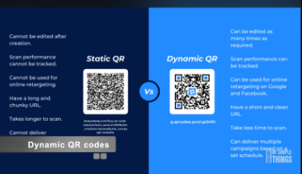
- 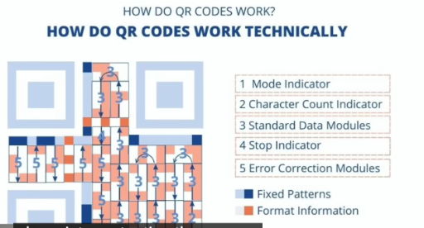
- 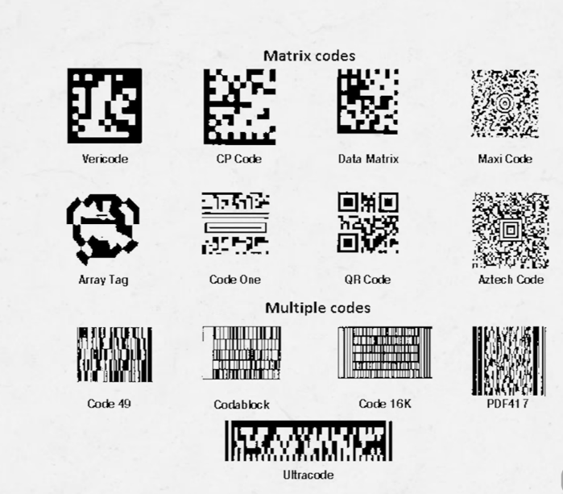

- are the key value pair stored in the form of hashmap in the npci mapper database हिन्दी +11 At a conceptual and architectural level, yes, the National Payments Corporation of India (NPCI) mapper database functions as a massive key-value lookup registry. However, it does not run on a simple in-memory programming structure like a standard Java HashMap. Instead, it uses enterprise-grade, highly optimized distributed databases to handle millions of real-time transactions.The technical breakdown of how data is structured and processed in the NPCI mapper includes the following components:The Key-Value SchemaConceptually, the database operates with a strict 1:1 mapping system designed for direct lookups:The Key: The Aadhaar Number (Unique Identification Number or UID).The Value: The IIN (Institution Identification Number) of the primary bank mapped to receive Direct Benefit Transfers (DBT).Why it is not a standard "HashMap"While a software engineer uses a HashMap for fast O(1) lookups in a running application's local memory, a country-scale infrastructure like NPCI requires persistence, fault tolerance, and absolute data consistency.Sharded Routing Tables: Rather than a single map, the underlying architecture employs sharded routing tables spread across distributed data clusters to balance massive request loads.NoSQL and Relational Engines: The actual storage layer utilizes heavily optimized relational systems or distributed NoSQL key-value stores rather than runtime application maps.Strict Constraints: Unlike a programming HashMap where keys can be easily overwritten or contain nulls, changing a value in the NPCI mapper requires strict cryptographic authorization, verification from the bank, and validation against a strict single-active-account pipeline.How the Lookup OperatesWhen the government initiates a payment switch transaction via the Aadhaar Payments Bridge System (APBS):The system reads the recipient's Aadhaar number (Key).It hits the central routing database to locate the matching IIN (Value).The funds are immediately redirected to the correct destination bank's core banking system.If you are looking into this for system design purposes, let me know if you would like to explore:The network request flow during a financial transaction.How data conflicts or overwrites are prevented when a user links a new bank.The security protocols used to protect data during routing.Medium·prasad CInternal Working of HashMap in Java? | by prasad C - Medium21 Jan 2026 — Key Characteristics of HashMap * Stores data as key → value pair. * Duplicate keys are not allowed. * One null key is allowed. * Multiple null values are allowe...QuoraHow are HashMap key values stored in memory? - Quora11 Jul 2017 — A HashMap is a data structure which stores and retrieves values based on Keys. A combination of Key-Value pair is called an Entry in a HashMap. When we need to ...NPCINACH – High Volume Repetitive Payment SolutionWhat is NPCI mapper? NPCI mapper is a repository of Aadhaar numbers linked with particular bank and used for the purpose of routing the Aadhaar based payment tr...StashfinAadhaar Bank Account Linking: NPCI Mapping Explained - Stashfin4 May 2026 — NPCI Aadhaar Mapping: The Single-Account Routing Pipeline NPCI mapping operates on a completely different network architecture. The National Payments Corporatio...Medium·Srikanth @logicThe fault lines of Aadhaar Mapper in digital payments - Medium24 Nov 2017 — Direct Benefit Transfer (DBT) through Aadhaar Payments Bridge. NPCI runs the Aadhaar Payments Bridge System (APBS, sometimes referred to as just APB), which ena...MediumUPI Architecture: The Story of How NPCI Became India’s L7 Super Switch | by Harsh Jha | Data And Beyond1 May 2026 — NPCI is a highly optimized L7 application gateway for UPI. It's not a bank, wallet, ledger, or user database. NPCI's architecture includes: * **Sharded routing ...Built InA Guide to HashMap in Java With Examples - Built In18 Jan 2024 — What Is HashMap in Java? HashMaps are a versatile and widely used data structure in Java, offering efficient access and manipulation of data based on unique key...cdpi.devMapper Architecture - G2P Connect10 Feb 2026 — Any Government-to-Person (G2P) Payments program requires two key identifiers to complete the final stage of the benefit disbursement process -. Beneficiary Iden...QuoraHow can I link an Aadhar in NPCI? - Quora7 Feb 2018 — * You have to give request to the bank employee by filling the form of aadhar seeding and opt of govt subsidy and also mention the link of aadhar by IIN no. Eac...Masai SchoolUnderstanding HashMap Data Structure With Examples13 Jul 2023 — So, What Exactly is a HashMap? A hashmap is a data structure that pairs keys to values. It uses a hash function to calculate an index into an array of buckets, ...Course HeroCorporate sends the customer mandate data in a hashed1 Mar 2022 — If a bank tries to map an Aadhaar number in NPCI mapper and if such Aadhaar number, if already mapped to another bank, subject to the new bank confirming that t...EnKashComplete Guide to NPCI Aadhaar Seeding and ...India's digital banking framework depends on clear identification and steady movement of funds across verified accounts. Aadhaar created the foundation for this...ScribdAadhaar Seeding and NPCI Mapping Guide | PDF | Authentication | Access ControlSelect Option - Aadhaar Linking Service 1) AUTH code – Authentication code 2) UID/VID – Aadhaar number virtual ID entered by Branch user 3) Response Description...SAP CommunityMapping Lookups to a Centralized Key-Value Store System - Integration of SAP PI/PO with Redis11 Jan 2016 — In order to fulfil these requirements, key-value store solutions are commonly heavily relying on in-memory and NoSQL technologies, providing capabilities for di...ScalerHashmap in Java11 May 2022 — HashMap in Java can also have null key and values. But there could be only one null key. However, there could be any number of null values corresponding to diff... AI can make mistakes, so double-check responses

18. COllect Request (UPI) – Simple Meaning (Matlab)
A Collect Request (also called a Pull Transaction) is a UPI feature where the receiver requests money from the payer (remitter) instead of the payer initiating the payment.
How it works
The receiver enters the payer's UPI ID (Virtual Payment Address - VPA).
The receiver sends a Collect Request.
The payer receives a notification in their UPI app.
The payer reviews the request and can Accept or Reject it.
If accepted, the money is debited from the payer's account and credited to the receiver.
Expiry (Validity) Rules
The receiver can choose how long the collect request remains valid.
Minimum validity: 1 minute
Maximum validity: 45 days
If the receiver does not specify an expiry time, the default validity is 30 minutes.
The PSP (Payment Service Provider, e.g., Google Pay, PhonePe, BHIM, Paytm) must provide an option for the customer to set this expiry time.
Example

Suppose Rahul owes Priya ₹500.

Priya sends a Collect Request to Rahul's UPI ID (rahul@okaxis) for ₹500.
Priya sets the expiry to 2 days.
Rahul receives the request in his UPI app.
If Rahul approves it within 2 days, ₹500 is transferred.
If Rahul ignores it and 2 days pass, the request expires automatically.
Key Points
Collect Request = Pull Money
Payment Request = Receiver initiates
Money is transferred only after the payer authorizes it
Expiry: 1 minute to 45 days
Default expiry: 30 minutes (if not specified)

This is different from a Pay Request (Push Transaction), where the payer directly sends money to the receiver without waiting for any approval request.

+++++++++++++++++++++++++++++++++++++++++++++++++++++++++++++++++

FINAL DAYS RESEARCH

Layer 1 — Transaction processing
Questions:
- Who initiates the transaction?
- What does the PSP app send?
- Which bank handles the debit?
- How does NPCI route the transaction?
- Which bank receives the credit?
- Where does authentication happen?
- Where is the UPI PIN involved?
- What messages are exchanged?
- What happens on timeout/reversal?

Layer 2 — Settlement
Questions:
- After transactions are processed, how do participating banks settle?
- What settlement infrastructure is used?
- What files/reports are generated?
- How are reversals represented?
- How are transactions reconciled?
- What happens if the transaction succeeds on one side but fails on another?

Question | Why it matters
Who processes the customer transaction? | Understand UPI flow
Who debits the remitter bank? | Identify trust boundary
Who credits beneficiary bank? | Identify second trust boundary
Who routes the transaction? | Understand NPCI's role
Who performs inter-bank settlement? | Understand financial finality
What files/reports are generated? | Understand reconciliation
What happens during reversal? | Identify failure scenarios
What happens if debit succeeds but credit fails? | Critical security/reliability case
How are duplicate transactions prevented? | Integrity/idempotency
How is reconciliation performed? | Detect inconsistencies

ANOTHER STUFF
MERCHANT SIDE

ABC Store
│
│ Customer selects "Pay by UPI"
▼
Merchant App
│
│ Request Reference ID
▼
Acquiring Bank / PSP
│
│ Reference ID + Amount
▼
Merchant App
│
│ Android Intent
▼
Customer's UPI PSP App
│
│ Payment request
▼
UPI
│
│ Route transaction
▼
Acquiring PSP
│
│ Validate Reference ID
│ Validate Amount
│
├── ❌ Invalid → Decline
│
└── ✅ Valid
│
▼
Translate Merchant VPA
│
▼
Merchant's Bank Account

SOME IMPORTANT POINTS—

- https://www.usenix.org/conference/usenixsecurity20/presentation/kumar

Possible Works
- What flow of protocols are there in UPI
  - Update of phone number/data
  - Registration
  - Payment from one phone to another
  - Linking and delinking the profiles
- What new things are added to UPI 2.0
- Look at the other research for UPI

Good directions for your own research:
- Re-run this methodology against current apps (2025/2026 versions of PhonePe, GPay, Paytm, and newer entrants like Navi, CRED, super.money, WhatsApp Pay, FamApp) to see whether device-binding, PIN-reset, and account-info-leak issues are actually closed today — direct extension of "preliminary UPI 2.0" section.
- UPI Autopay / recurring mandates, UPI Lite, Credit-Line-on-UPI, and RuPay-credit-card-on-UPI are newer surfaces NPCI added post-2020 that this paper never touches — worth a fresh threat model.
- International UPI corridors (UPI now operates across ~8 countries) introduce new bank/telecom trust boundaries not analyzed here.
- NPCI's 2025 Information Security Framework and OC-215 API guidelines — an empirical audit of whether real deployments actually meet these mandated controls (a compliance-gap study) would be a natural follow-on.
- SMS ecosystem attacks (SS7, SIM swap, spoofed sender IDs) as an alternative path to the same device-binding weakness — the authors flag this as unfinished work themselves.
- Given the growing market-share fragmentation (PhonePe/GPay combined share fell below 80% for the first time in May 2026 as smaller apps grow), it's worth checking whether smaller/newer TPAPs have weaker security posture than the big two, echoing the original PhonePe/Paytm/Samsung-Pay "third-party integration is weaker" finding from this paper.
- A direct technical follow-up: reverse-engineer a sample of the newer OS-manipulating toolkits (Digital Lutera-class) the way Kumar et al. reverse-engineered BHIM — is SIM-binding really being defeated at the OS layer, or is it a rooting/Magisk-style trick?
- Quantify the malware-vs-pure-social-engineering split with more recent I4C/NCRB FIR data (2024–2026) instead of the 2019–2020 Gurugram sample this article relies on.
- Evaluate whether RBI's newer mandates (AI/ML fraud monitoring, zero-trust bank architecture, mandatory device-SIM binding via DoT, biometric authentication for transactions >₹10K) are actually closing the gap this article identifies, or just adding friction without addressing the malware-permission-abuse root cause.
- A user-research angle matching this paper's own method: re-run the low-income/new-to-UPI interview study in 2026 to see if awareness has improved given NPCI/RBI campaigns since 2023 — a natural extension given Dvara's own stated "unfinished agenda" of awareness-campaign gaps.
- RASP effectiveness benchmarking — build a testbed comparing detection rates of different root-cloaking/Frida-hiding techniques (e.g., Magisk Hide variants, Shamiko) against common RASP SDKs; quantify false positive/negative rates.
- ML-based anomaly detection on the "Detect" layer — using the tamper-detection telemetry categories the circular describes (system calls, file access, network patterns), prototype a lightweight on-device or edge anomaly classifier and compare against rule-based tamper detection.
- OTP/SMS-based social engineering resilience — study how sender-ID spoofing and OTP-relay attacks (SIM swap, OTP-relay malware) can still bypass sender-ID whitelisting; propose cryptographic or app-attestation-based alternatives to SMS OTP.
- Screen-overlay/tapjacking detection techniques — comparative study of Android's accessibility-service abuse detection methods vs. this circular's mandated approach; potential for a formal detection algorithm.
- Cost-benefit/adoption-friction analysis — a compliance-economics study: interview or survey smaller PSPs/TPAPs (cooperative banks like RSCB itself are a great case study) on implementation cost/complexity of CERT-IN audit + RASP integration vs. large banks — relevant policy research on whether uniform mandates disproportionately burden smaller players.
- Formal comparison to global standards — map this framework against PCI-MPoC, PSD2/SCA (EU), and OWASP MASVS to identify gaps/overlaps — useful if you want an angle connecting back to the international UPI expansion question.
- Adversarial ML angle — if your background leans ML: model how attackers could use generative AI to synthesize behavioral patterns that evade the "behavioral analysis" reverse-engineering detection (point 22 in the circular) — a red-team research paper.
- a new registration pathway is exactly the kind of "alternate workflow" category that caused the original 2020 vulnerabilities, so it's worth asking whether this Aadhaar-based path has had the same scrutiny.
- International UPI corridors introduce a genuinely new threat-model question the original papers never had to consider — foreign telecom SIM issuance doesn't go through India's ID-verification regime, so the "device hard-binding relies on trustworthy telecom-issued numbers" assumption baked into UPI's core design may not hold uniformly across all these corridors. That's a solid, underexplored thread for your research.
- The genuinely novel research question this opens up for you: how does an AI agent get authenticated for a payment, and what happens if that agent is manipulated (e.g., via prompt injection, if it's an LLM-based assistant) into authorizing a transaction the user didn't intend? That's a real, unstudied intersection between your two skill areas — UPI protocol security and AI/agent security — and as far as I can tell from what's public, nobody has published a technical analysis of it yet. That's a stronger thesis angle than re-testing 2020's device-binding attacks, which at least three circulars now claim to have addressed.

